**Lab Tasks**

1. Write a C++ program to check whether a given number is prime or not. Allow the user to input a number and display whether it's prime or not?
2. Create a C++ program to handle student marks management. The program should allow users to input marks for students in four courses: PF, OOP, DLD & ICT. It should then calculate the total marks, average marks, and determine the grade for each student based on their average.

Use the following grading metrics:

90 or above: Grade A

80-89: Grade B

70-79: Grade C

60-69: Grade D

Below 60: Grade F

1. Write a program to make a simple calculator performing the four basic operations (+, -, *, /) on two numbers input by user. The following conditions must be satisfied:

a) A ‘+’ sign must not be used for addition.

b) You can only use a maximum of 3 variables. No more variables are allowed.

c) Your program should ask the user which operation he/she wants to perform and gives the output accordingly.

1. Write a program to take an integer array as an input from user and count all the even and odd numbers in that list and print the counts.
2. Write a function that will take a number 'n' input by user and will return its factorial.
3. Imagine you are working on a project where the efficient generation of odd numbers is crucial. Your task is to write a C++ function that prints an odd number after every sequence of 5 even numbers in the range provided by the user. The catch is that you need to optimize the program for both correctness and efficiency.

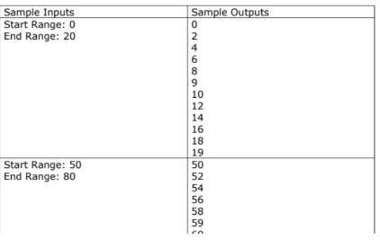

1. You are hired as a billing manager at K-Electric. Your task is to calculate the monthly bill according to the units consumed. Write a program to input electricity unit charge and calculate the total electricity bill according to the given condition:

For first 50 units Rs. 0.50/unit

For next 100 units Rs. 0.75/unit

For next 100 units Rs. 1.20/unit

For unit above 250 Rs. 1.50/unit

An additional surcharge of 20% is added to the bill.

